SOUTHWEST COMPANY
Student
Institution
Date
Question 1
The grade for the Southwest Top Management Team
The system of the organization is at an upright state since it guaranteeing that it is at a position of being a nominal effort benefactor, and it isn't providing relinquishes of a slight style of exchange flights, (Arthur and John, 2016, p.2). This can be the reason that makes me love the southwest procedure increasingly as a result of their stay on the strategy within the entire process, as a result of their improved process, I will give Southwest grade A.
Major policies, operating practices, procedures and core values
The Southwest Airline has the following policies; the organization guarantees visit flights, maintaining the low expenses, low fares and guaranteeing that there's a fast extension of its corporate into the new urban communities. The organization has an added advantage of making contracts that are of positive perspective since it'll get its fuel with ease, (Arthur and John, 2016, p.22). This has thus prompted the organization in remarkably beating her rivals since it is creating big advantages that are unit persuasive to maintain the company’s stability. Southwest Airline operating some practices that are more productive, that is, which is giving more thoughtfulness relating to customers and reducing prices. The fundamental beliefs of the organization are that it guarantees that it keeps up its outputs, ensuring the procedure smooth, dominant expenses, securing the best position in the market in terms of customer service ratings, as well as utilizing the electronic ticketing. Southwest Airline organization has, besides, existent its ease strategy by guaranteeing there's a high level of teamwork, and therefore, the harmonization of the employees is a reason behind the successful implementation through the people that are behind the productive execution.
My likes and dislikes on the strategy
The strategy of the Southwest Airline executive team that I like is that of making contracts that are of positive perspective to get its fuel in ease. The strategy that I don't like is that of using low prices since customers might associate low prices with sub-standard services.

Question 2
My opinion on execution and implementation of the organization’s strategy
I fully agree that Southwest Airline organization has had proper management simply because it has been in a good position of executing out the policy by guaranteeing that it is giving low expenses, avoiding giving penalties on delayed flights.
The strategy execution approaches as well as operating practices that I believe is more important in accounting for the success of the Company.
Being in the major airline in, Southwest Airline as been pushing to attain its strategy of administration. In the process of implementing the policies and management, the company is at another high level. The execution techniques and viable practices that are more important are management and low-cost has been discussed below, (Arthur and John, 2016, p.2).
The strategy of low-cost
The management of Southwest Airline corporation executed the same strategy that guarantees that the cost that the customers have to incur when buying tickets is minimized and consequently ensuring that flights obtain will be affordable to the customers. There are significant efforts that are created for the present strategy. The organization has been utilizing a specific style of flying aircraft with main aim of minimizing the time of operations and value. Southwest Airlines is the first airline organization to come up with the ticketless framework that's cost accounting $1 as a choice of $4. The organization likewise executes strategies that are directed to reducing the extra charges, saving time on travelers, and rising technology. The organization, also, guarantees that it was upholding the quality of their service, (Amorim Neto et al, 2018).
Management
Kelleher, being the CEO, guarantees that the tasks of the organization are successively commendable by warranting that teamwork is improved. The CEO does this by involving the employees in decision making.
The administration of the organization strives to guarantees that the employees have a good rapport with the organization’s management. As an example, the employees suggested that the organization ought not to place logos on refuse packs, and therefore, the recommendation was implemented saving $250000 per annum, (Arthur and John, 2016). The organization contains a substantial certainty of giving the employees their priority, then the customers. The aforementioned gives the employees morale to work and thus more products as well as keeping workers contented. When the employees are contented, then the customers contended.
The management in the company ensured that they employed staff with needed requirements and intended skills. This can be the main motivation behind why the employees possessed a hardworking motive. The selected staffs that manages recruitment of new employees in the organization did a careful investigation of every activity category with main aim of ascertaining specific job exhibitions knowledge that the stakeholders needed so that they can utilize the foretold attributes This was a positive thought because the administration prompted obtaining proficient workers that are ready to work along their areas of specialization. The aforementioned has thus prompted the organization to gain more additional to the company customers, thus increasing the profits.
The Policies, the operating approaches and procedures at Southwest Airline organization that I disapprove or that are not working as expected.
I think that there aren't any completely different approaches in Southwest Airlines that I denounce since I feel that it is operating at its high level. With determination, the company can work on its threats and weaknesses thus being the best airline company in the world.

Question 3
The elements of the culture of Southwest
The major elements of the culture
The significant elements of company's culture are; the company is full of fun associated with tantalizing work and is being improved over participating exhibitions in their employments, providing exactly what they promise and quips, High pay, as well as allurements and regular organization, supported parties and festivals.
Southwest Airlines see their culture to be jointly hence can operate on anything that they will operate on anything one they can think of. Kelleher, the CEO, has modified the Southwest Airline organization into being a big carrier, and it is absolutely. Moreover, the CEO is mandated to check the companies to ensure that they get no challenge, thus completing their activity well. Kelleher treated the workers as if they are family members.
Whether corporate culture is influential, with reason
In my perception, the company culture is robust since it guarantees the workers unity. Through the aforesaid, the workers will add a perfect domain on these lines; hence, high profits are gained.
Whether Gary Kelly will face a challenge while sustaining the culture after the departure of Kelleher.
In my thinking, Gary Kelly will not face challenges in supporting Southwest's Airline's theory since he can pursue the precise strides of Kelleher, the outgoing CEO. Herb Kelleher is recognized as the one who stabilized operations and policies of the Southwest Airline organization, making it exceed the organization's rivals. Kelleher has faith in Kelly that he will accomplish a lot of achievements making the creating the airline organization to ascend to extraordinary heights. The incoming CEO is keen on staying with them to be the simplest among others in the world, and this can likewise be one thing that is useful for both employers and customers, and it'll be tired done appropriately. Kelleher has been operating under strategy that is based on satisfying the management team to keep working, and henceforward Kelly should come up with a plan that will ensure the policies are implemented as expected. Kelly can likewise guarantee that the organization's quality balance sheets reports are preserved to pointers and keeping high profits and minimal debts. In order Kelly to maintain a strategic distance from challenges in futures, Kelly should guarantee that the organization is frequently running at high defiance, low prices, and solely treating all employees equally as well as the customers.

Question 4
Definition of “triple bottom line” and it’s relation to social responsibility and ethics
Triple bottom line can be defined as a framework and theory that recommends the organization to put more effort on environmental concern and social concerns as they focus more on the profits. TBL relates to the ethics and the corporates responsibility in that it ensures that the operation of the company has a minimum or has no negative impact on both the immediate social life and environment. To discuss this, four concerns need to be looked at; which are people, planet and profit, (Chishty-Mujahid, 2017).
People
With regards to people, the employees are thought of in terms of the duties designated to them. Another methodology for determining how the company is ethical to the people is done by ascertaining how useful and beneficial to the community. The organization guarantees that the wages are paid and guarantees that the employees are operating in healthy environments.
Planet
With regards to the planet, the ideology is that if the organization does affect the environment negatively, they got to acknowledge the expense. The "planet" in this framework shows that any organization got to limit its ecological impression the maximum amount as possible. This could be possible by guaranteeing that they need to have a good way of depositing waste, utilizing property power supply, and utilizing alternative characteristic assets.
Profit
In the triple bottom line concern, every organization has to guarantee that it is financially profitable. This is the main objective of every company.
Corporate social responsibility of a company is a practice that guarantees the activities of the organization are helpful to society at large. The connection that exists between ethics and corporate social responsibility and ethic and the TBL is that the interests of TBL are guaranteeing that the organization operates taking care of the society and also economy while company social responsibility combines the social and the environmental problems consequently deciding on appropriate solution, shaping objectives and guaranteeing that business are running as expected.. Concerning morals, it guarantees that the interests of the staff, clients, partners, and also the network once all is alleged in done are met because the TBL guarantees that the planet, civilization, and also the economy as a rule.
Whether Southwest is socially responsible
I think Southwest corporation is socially responsible. The aforesaid can be based because the organization has gone to a further mile in ensuring that immediate community is not affected negatively by the company operation. This is evidenced when the organization provides gifts and compensating those affected. The organization is committed to ensuring the preservation of the planet. The organization is determined at providing safe working environments. Moreover, the company guarantees maintaining the TBL of the planet, the people and the profit.

Whether anything should be done differently in this regard
In my perception, the organization has to guarantee that it accomplishes its social corporate responsibility. This is based on grounds that there is very high competition, the Southwest organization has to be in a state of affairs to administer outstanding services and product to their customers as well as cooperating with its partners, customers, and also the employees.

Question 5
Southwest SWOT analysis
Strengths
The strengths of the Southwest Airline organization and it's a major success is the cost management. This organization is the biggest airline company operating in USA, and it offers varied types of travellers. Southwest organization is the best organization as it records more than 3,000 flights daily. Moreover, the company has built its image which makes the company be the most preferred. The high incomes from operations of the organization have indicated a growing pattern, and therefore, it makes the organization ensure steady development system.
Weaknesses
Notwithstanding the organization being the best airline within the USA, it operates on the local market. The organization has been performing throughout the previous forty years, and it should have ventured to the global market. Furthermore, the company lacks the morning flights and hence making the market to be limited, (Kunnanatt, 2016).
Opportunities
The organization has completely different opportunities that may cause it to turn into the worldwide operation. The organization has to ensure that it comes up morning flights with the goal attracting additional customers. More opportunity that the organization has is that it can increase the passenger's capacity while still maintaining a low price. The company can also improve customer service so that they can be more competitive. The Airline organization will likewise utilize a high cost in finishing its research which will help in improving its operation. Its low-value prices and give discounts.
Threats
Some of the threat that Southwest Airlines organization is encountering is that it’s not in a very stable position of affairs to get into the international market. The other competitive companies are adopting the same strategy of low- price strategy. This so prompts a healthy competition to Southwest Airlines in its region of doing its operations. Other threats are an increase in fuel prices and terrorism attacks, (Heizer et al, 2016).
Strategic issues and problem that Southwest executive under Gary Kelly should be addressed in mid of the year 2016
So far, the organization analysis shows that it's performing massively well. The methodologies and problems that Garry and also the executive ought to look at are as follows; firstly, the Southwest organization has to take a look at the competition business with the goal that it will maintain its high competition in the future. Secondly, Gary and the management have to look at how to increase its operations into large airports and to take new routes to raise the number of customers.

Question 6
Analysis of the company’s financial info
The table and chart below show the financial analysis of organization in recent times. The report has been calculated for the actual three years which are 2016,2017,2018, and also the estimated figures in millions of three years, 2019-21.

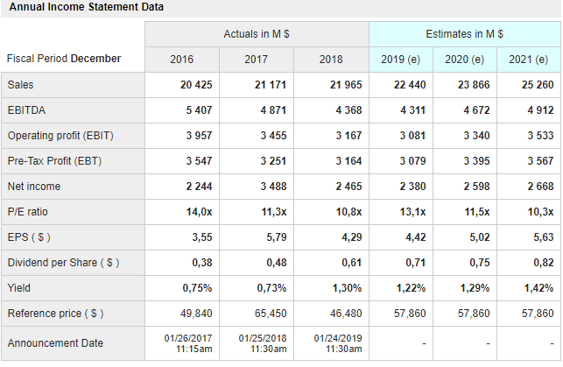
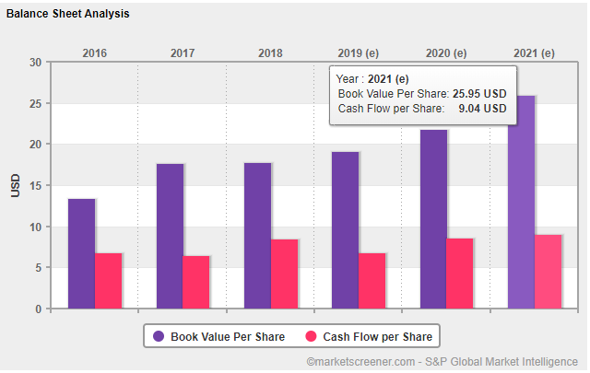

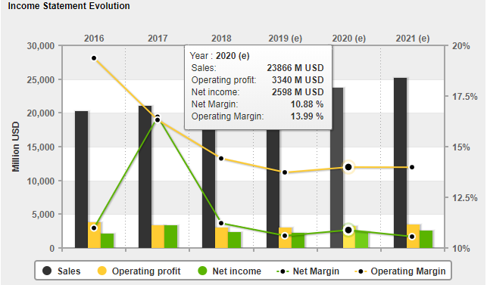

The components of the SWOT that have changed
The organization has the potential of developing on the off probability that it will utilize new procedures in controlling, business extension, and guaranteeing that new associations are formed. New organizations can be accomplished by allying with non-aircraft companies, and this will open their operations to the global market.
My recommendations to the executive team of the Southwest company to move forward
My recommendation is that Gary should consider raising the number of flights into new routes so that there could be increased profits and make sure that flights are reduced in the regions where there are low passengers. Lastly, the company should focus on offering the best services to the customer since customer is the boss.

References
Arthur A. Thomson & John E. Gamble. Southwest Airline in 2016: Culture, values and operating Practices. 2016.
Amorim Neto, R. D. C., Bursey, A., Janowiak, D., Mccarty, C., & Demeter, B. (2018). Teamwork and motivation to leave the teaching profession: An exploratory study. Journal of Education, 198(3), 215-224.
Heizer, J., Render, B., & Munson, C. (2016). Principles of operations management: sustainability and supply chain management. Pearson Higher Ed.
Kunnanatt, J. T. (2016). 3D leadership–Strategy-linked leadership framework for managing teams. Economics, Management, and Financial Markets, 11(3), 30-55.
Chishty-Mujahid, N. (2017). Southwest Airlines’ successful economistic, cost-leadership strategy examined in light of Paul Lawrence’s renewed Darwinian theory: An analysis. Journal of Global Business Insights, 2(2), 115-123.
https://www.youtube.com/watch?v=FI6dT0zMRB4.
https://www.youtube.com/watch?v=j0ibULnU8_s

